**Ex 19-1 # 1:**

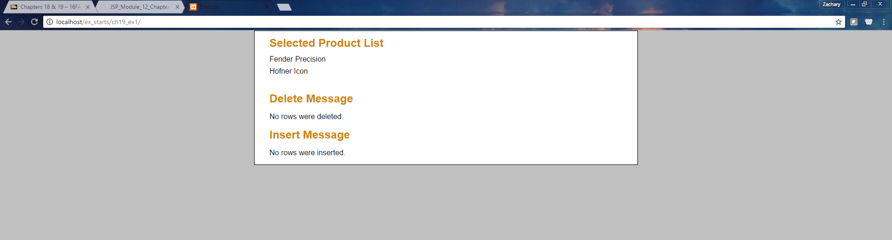

Ran the application successfully.

**Ex 19-1 # 2:**

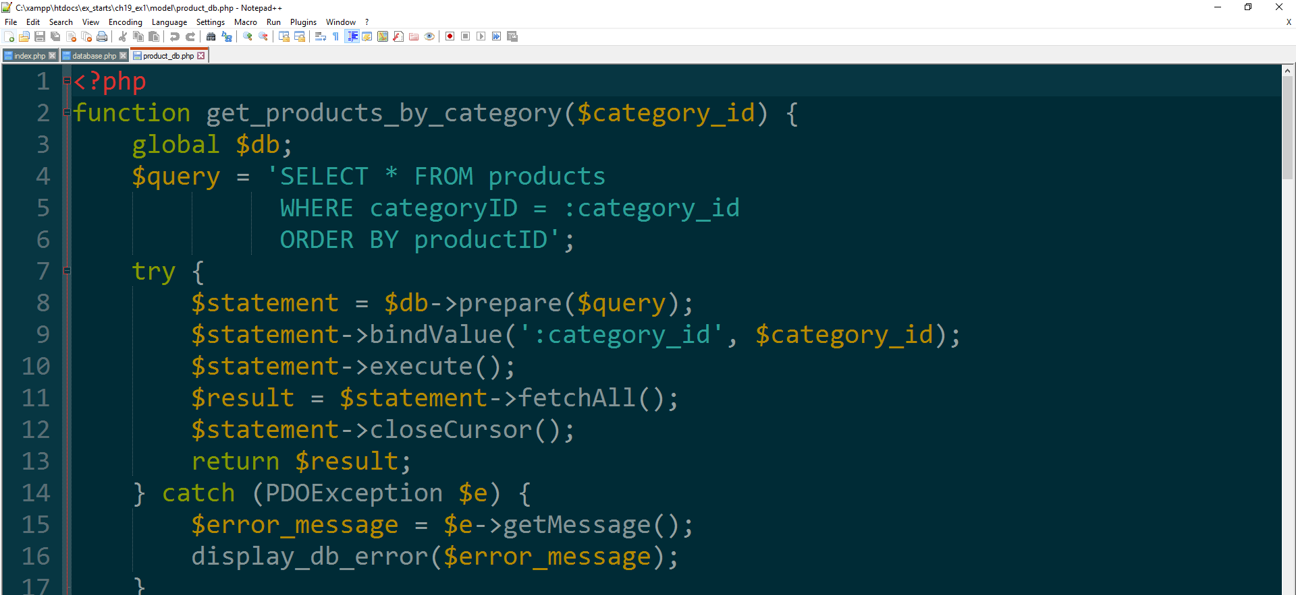

All files open in text editor.

**Ex 19-1 #9:**

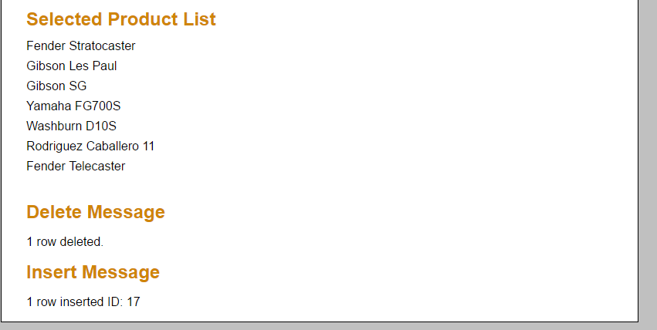

Code works as expected.